Ross L. Winans
June 26, 1935 – May 26, 2019

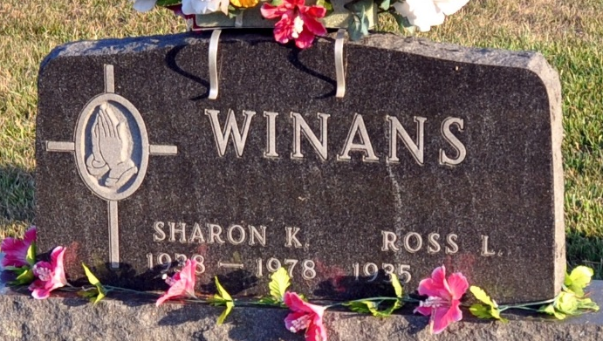
Photo by Deb Curry
Ross L. Winans, 83, of Decatur, Indiana passed away on Sunday, May 26, 2019, at Lutheran Hospital in Fort Wayne, Indiana. He was born on June 26, 1935 in Decatur, Indiana to the late Elmer E. and late Lilly T. (Thomas) Winans. He married Sharon K. Raber on June 30, 1956 and Sharon preceded him in death on October 28, 1978. Ross was united in marriage to Rita Ehrsam on July 10, 1981 in Pleasant Mills and she survives.
Ross was a member of Pleasant Mills United Methodist Church and served as a former trustee and Sunday School Teacher for several years. He was also a former member of the Pleasant Mills Lions Club and Adams County Conservation Club. He was a 1954 graduate of Pleasant Mills High School. After high school Ross worked as a Machine Repairman at International Harvester before retiring in 1985 following 30 years of service. Ross enjoyed fishing and hunting but especially fishing.
He is survived by his wife, Rita Winans of Decatur; daughter, Linda (Tim) Snider of Decatur; son, Daniel (Pam) Winans of Decatur; daughter, Joan (Sam) Falk of Decatur; step-daughter, Carol Sue (Allan) Hill of Decatur; step-son, Timothy (Janet) Clouse of Birdseye, Indiana; sister, Grace (Ronnie) Bryan of Monroe; brother, Jerry (Janice) Winans of Springfield, Ohio; eight grandchildren; 5 step-grandchildren; 9 great-grandchildren; and four step-great-grandchildren. Preceded in death by a son, David Winans; grandson, Jason Snider; step-granddaughter, Shelly Whitacre; great-granddaughter, Sharon Tonner; three brothers, Harvey, Richard & Donald Winans.
A funeral service will be held at 10:00 a.m. Friday, May 31, 2019, at the Zwick & Jahn Funeral Home – Decatur with Pastor Ernie Suman officiating and burial will follow in Decatur Cemetery. Family and friends will be received from 2-8 p.m. Thursday, May 30, 2019, at the Zwick & Jahn Funeral Home – Decatur and one hour prior to the service on Friday.
Preferred memorials are to be made to Pleasant Mills United Methodist Church.

Zwick & Jahn Funeral Home, Adams County, Indiana
Sunday, May 26, 2019

