Marie Annette (Rowdon) Winans-Rauch
August 28, 1933 -

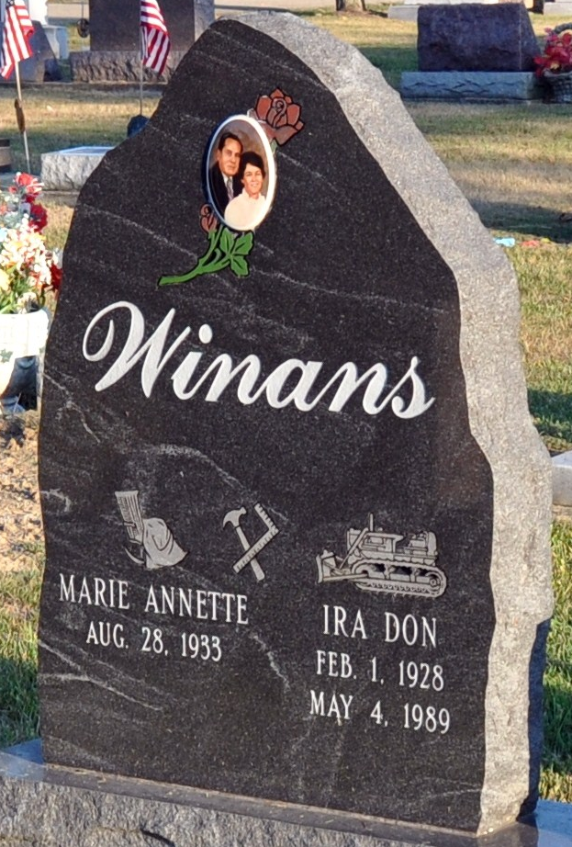
Photo by Deb Curry
Marie Annette Winans
in the Indiana, U.S., Marriage Certificates, 1960-2012

Name Marie Annette Winans
[Marie Annette Rowdon]
Gender Female
Marriage Age 63
Birth Date abt 1934
Birth Place Detroit, Michigan
Marriage Date 19 Jul 1997
Marriage Place Monroe Center, Adams, Indiana, USA
Marriage Registration Date 1997
Father Clarence Rowdon
Mother Fern Rowdon
Spouse John Bernard Rauch
Description Union-Hendricks
Notes 2 N; Reference Number 1 Bx1450; Reference Number 2 Tr8506 Certificate Number 021525; Box Number Box 5h

