Quincy R. Winans
October 30, 1884 – November 14, 1960

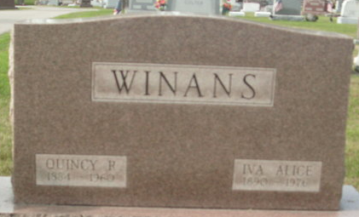
Photo by Deb Curry

QUINCY R. WINANS DIES AT FORT WAYNE
Quincy R. Winans, 76, a native of Pleasant Mills and former Decatur resident, died Monday night at his home, 3033 Barr Street, Fort Wayne. He had been in poor health for several months but his death was unexpected. He attended school in Decatur and the Evangelical Church and moved to Fort Wayne about 40 years ago.
Mr. Winans retired a number of years ago from the General Electric Co. He was a member of the Evangelical United Brethren Church.
Surviving are his wife, Iva; a son, Carl; two granddaughters; one brother, Ed Winans of Fort Wayne; and three sisters, Mrs. Jesse Niblick of Decatur, Mrs. M. B. Large of Kalamazoo, Mich., and Mrs. L. D. Clark of Dayton, O. Three brothers and one sister are deceased.
Funeral services will be conducted at 1 p.m. Friday at the C. M. Sloan & Sons Funeral Home, the Rev. Ervin E. Petznik officiating. Burial will be in the Decatur Cemetery.

Decatur Daily Democrat, Adams County, Indiana
Wednesday, November 16, 1960

**
Indiana, Death Certificates, 1899-2011
Name: Quincy R Winans
Gender: Male
Race: White
Age: 76
Marital status: Married
Birth Date: 30 Oct 1884
Birth Place: Pleasant Mills, Indiana
Death Date: 14 Nov 1960
Death Place: Rural, Wayne, Indiana, USA
Father: Joseph Frank Winans
Mother: Eleanor McCullough
Informant: Richmond State Hospital records; Richmond, Indiana
Burial: November 18, 1960; Decatur Cemetery; Decatur, Indiana

