Leah Dove (Roe) Winans
July 29, 1890 – January 5, 1970

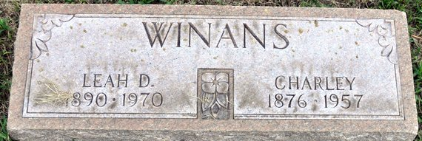
Photo by Deb Curry
MRS. LEAH WINANS DIES AT FORT WAYNE
Mrs. Leah (Dove) Winans, 79, of Maycrest Drive, Fort Wayne, died late Monday night at her home after an illness of two months. She was a native of Pleasant Mills and had lived in Fort Wayne 52 years. She retired in 1957 from the Wayne Pump Canteen.
Mrs. Winans was a member of the North Highlands Church of Christ.
Surviving is a son, Charles Winans, with whom she lived; five grandchildren and three great-grandchildren.
Funeral services will be held at 10:30 a.m. Thursday at the North Highlands Church of Christ, with Robert F. Yawberg and Donald L. Akin officiating. Burial will be in the Decatur Cemetery. Friends may call at the Klaehn Funeral Home from 2-5 p.m. and 7-9 p.m. today and after 9:30 a.m. Thursday at the church.

Decatur Daily Democrat, Adams County, Indiana
Wednesday, January 7, 1970
**
Indiana, U.S., Death Certificates, 1899-2017
Name Leah Winans
[Leah Roe]
Gender Female
Race White
Marital Status Widowed
Age 75
Birth Date 29 Jul 1890
Birth Place Indiana
Death Date 5 Jan 1970
Death Place Fort Wayne, Allen, Indiana, USA
Father Joel Roe
Mother Elzann Frank
Informant Charles Winans; son; Fort Wayne, Indiana
Burial January 8, 1970; Maplewood Cemetery; Decatur, Indiana

