Joseph Franklin Winans
February 22, 1855 – January 17, 1934

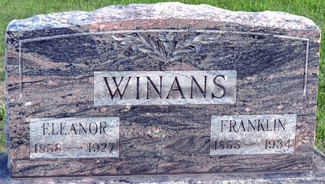
Photo by Deb Curry
Indiana, U.S., Death Certificates, 1899-2017

Name Joseph Franklin Winans
Gender Male
Race White
Marital Status Widowed
Age 78
Birth Date 22 Feb 1855
Birth Place Pleasant Mills Indiana
Death Date 17 Jan 1934
Death Place Decatur, Adams, Indiana, USA
Death Registration Date 1934
Father Joseph Ross Winans
Mother Nancy Heath
Informant Ed Winans; Fort Wayne, Indiana
Burial January 19, 1934; Decatur Cemetery

**
Franklin Winans
in the Indiana, U.S., Marriage Certificates, 1960-2012
Name Franklin Winans
Gender Male
Marriage License Date 20 Nov 1880
Marriage Date 21 Nov 1880
Marriage Place Adams, Indiana, USA
Spouse Ella McCullough
Officiator Wm H M France

