Iva Alice (Miller) Winans
January 8, 1890 – April 19, 1976

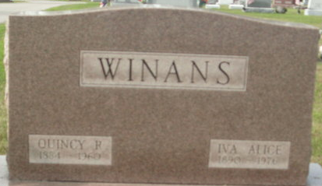
Photo by Deb Curry
Iva A. Winans
in the Indiana, U.S., Death Certificates, 1899-2017
Name Iva A. Winans
[Iva A. Miller]
Gender Female
Race White
Marital Status Widowed
Age 86
Birth Date 8 Jan 1890
Birth Place Ohio
Death Date 19 Apr 1976
Death Place Fort Wayne, Allen, Indiana, USA
Death Registration Date 1976
Father Willard E. Miller
Mother Cora B. Hitchcock
Informant Earl Miller; brother; Fort Wayne, Indiana
Burial April 22, 1976; Decatur Cemetery; Decatur, Indiana

