Ira Donald Winans
February 1, 1928 – May 4, 1989

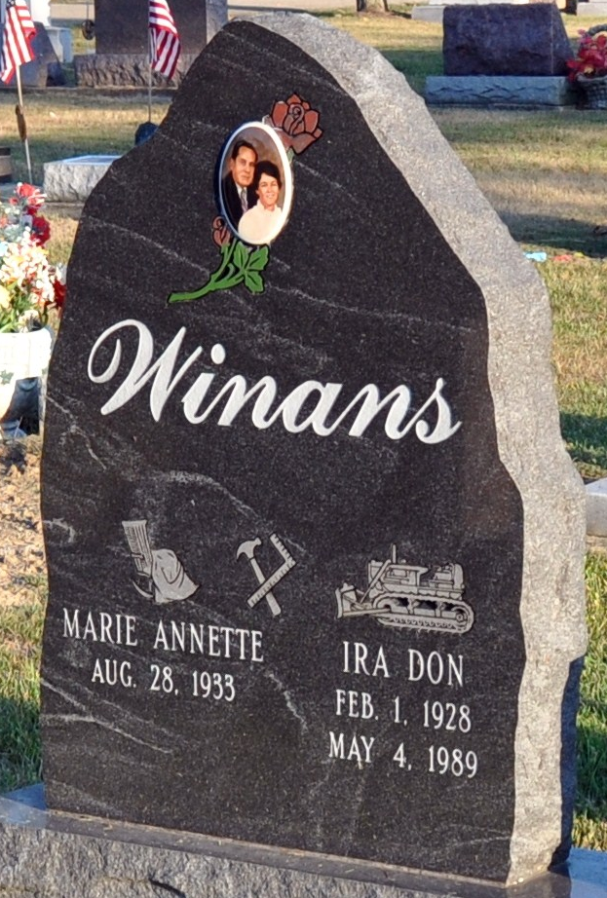
Photo by Deb Curry
Ira Donald "Don" Winans, 61, Casey Illinois, who has relatives in Adams County, died at 5:19 a.m. Thursday in Union Hospital, Terre Haute.
The native of Spokane, Washington, married the former Marie Rowdon, who survives. He was a gang foreman in the pipeline division of Marathon Oil Co. for 38 1/2 years.
Other survivors are three sons, Clarence E. Winans, Palatka, Florida; Gregory D. Winans, Slaughter, Louisiana; and Douglas W. Winans, Lockport, Illinois; three brothers, Richard Winans, Decatur; Ross Winans, Route 4, Decatur; and Jerry Winans, Springfield, Ohio; one sister, Mrs. Ronald (Grace) Bryan, Monroe; and six grandchildren. One brother, Harvey, is deceased.
Funeral services are at 10:30 a.m. Monday in Haggard and Armes Funeral Home, Rev. Jual Evans officiating. Burial will be in Decatur Cemetery. Visiting hours are 2-9 p.m. Sunday.
Preferred memorials are to the Cancer Fund.

Decatur Daily Democrat, Adams County, Indiana
Friday, May 5, 1989
**
Decatur – Ira "Don" Winans, 61 died Thursday in Union Hospital, Terre Haute. He was an employee of Marathon Oil Co.
Surviving is his wife, Marie; three sons, a sister, three brothers; and six grandchildren.
Services are 10:30 a.m. Monday in Haggard & Armes Funeral Home, where calling is 2 to 9 p.m. tomorrow. Burial will be in Decatur Cemetery.
Preferred memorials are gifts to the American Cancer Society.

News Sentinel, Allen County, Indiana
Saturday, May 6, 1989
**
Indiana, U.S., Death Certificates, 1899-2017
Name Ira Donald Winans
Gender Male
Race White
Marital Status Married
Age 61
Birth Date 1 Feb 1928
Birth Place Washington
Death Date 4 May 1989
Death Place Terre Haute, Vigo, Indiana, USA
Death Registration Date 1989
Father Elmer Emerson Winans
Mother Lillie J Thomas
Spouse Marie Rowdon
Informant Mrs. Marie Winans; wife; Casey, Illinois
Burial May 8, 1989; Decatur Cemetery; Decatur, Indiana

