Elmer E. Winans
April 5, 1883 – February 27, 1965

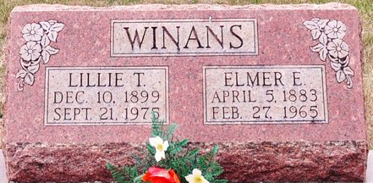
Photo by Deb Curry
Elmer E. Winans Dies This Morning

Elmer E. Winans, 81, retired St. Mary's Township farmer, died at 2 o'clock this morning at his home, two miles southwest of Pleasant Mills. He had been in failing health for the past five years. A resident of St. Mary's township most of his life, he was born to Joseph and Isabel Archer-Winans April 5, 1883, and was married to Lillie Thomas Nov. 16, 1922.
Mr. Winans attended the Methodist Church.
Surviving are his wife; five sons, Harvey D. Winans, master sergeant in the U. S. Air Force in Madrid, Spain, Richard G. Winans, at home, Ira D. Winans of Wapakoneta, O., Ross L. Winans of Decatur route 6, and Gerry T. Winans of Decatur; one daughter, Mrs. Ronald (Grace) Bryan of Monroe route 1; and 14 grandchildren. Two children and two sisters are deceased.
The body was removed to the Zwick Funeral Home, where friends may call after 2 p.m. Sunday. Funeral arrangements have not been completed, but the Rev. Joseph Gibson will officiate and burial will be in the Decatur Cemetery.

Decatur Daily Democrat, Adams County, Indiana
Saturday, February 27, 1965

**
Indiana Births, 1880-1920

Name: Winans, ___
Father: I. D; Mother: Belle Arkey
County: Adams; Gender: Male
Birth Date: 5 Apr 1883
Reference: Adams County, Indiana Index to Birth Records 1882 - 1920 Inclusive Volume I Letters A - Z Inclusive;
Book: H-1, Page: 74

