David Lee Winans
November 25, 1958 – July 29, 2016

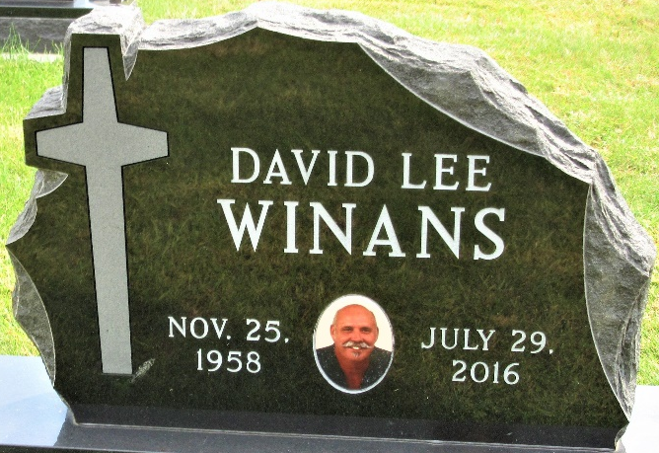
Photo by Deb Curry
David Lee Winans, 57 years old of Decatur, IN, passed away on Friday, July 29, 2016 in his sister’s residence located in Decatur. He was born on November 25, 1958 in Decatur, IN. David is the son of Ross Winans and the late Sharon Kay (Raber) Winans.
David attended Union Chapel United Methodist Church, Decatur. He was also a lifetime member of the NRA. He received numerous awards for sporting clay competition. David also loved to elk hunt in Colorado. He was currently employed as a toolmaker with GT Automation Group of Ft. Wayne. He was previously employed with Ajax Tool Inc.
Surviving are his father, Ross & Rita Winans of Decatur, IN; sister, Linda (Tim) Snider of Decatur, IN; brother, Daniel (Pamela) Winans of Decatur, IN; sister, Joan (Sam) Falk of Decatur, IN; step-sister, Carol Sue (Allan) Hill of Decatur, IN; and step-brother, Timothy (Janet) Clouse of Birdseye, IN.
Funeral services will be held at 10:30 a.m. Wednesday, August 3, 2016 in the Union Chapel United Methodist Church 2999 E. 700 N. Decatur, IN with Pastor Ed Karges officiating. Interment will follow in the Decatur Cemetery. Friends will be received from 2-8 p.m. Tuesday, August 2, 2016 in the Zwick & Jahn Funeral Home Decatur and one hour prior to the service Wednesday at the church.
Preferred memorials are to Family LifeCare Hospice, Berne.

Zwick & Jahn Funeral Home, Adams County, Indiana
July 30, 2016

