Clarence A. Winans
January 3, 1912 – August 11, 1924

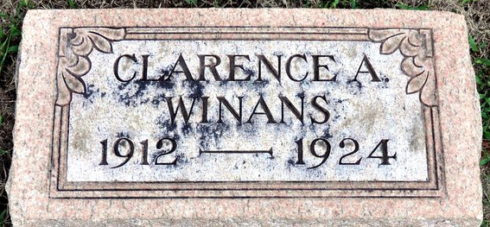
Photo by Deb Curry
Clarnce A. Winans
in the Indiana, Death Certificates, 1899-2011
Name: Clarnce A. Winans
Gender: Male
Race: White
Age: 12
Marital status: Single
Birth Date: 3 Jan 1912
Birth Place: Pleasant Mills, Ind.
Death Date: 11 Aug 1924; meningitis
Death Place: Adams, Allen, Indiana , USA
Father: Chas. Winans
Mother: Leah Roe
Informant: Chas. Winans; Fort Wayne, Indiana
Burial: August 13, 1924; Decatur, Indiana

