Charley Winans
December 7, 1876 – August 11, 1957

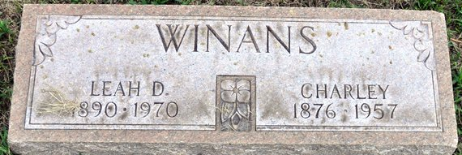
Photo by Deb Curry
Chas. Winans Dies At Fort Wayne Home
Native Of County Is Taken By Death
Charley Winans, 80, a native of Adams County, died at 8:05 o’clock Sunday morning at his home on Malcret Drive in Fort Wayne. He had been ill for the past eight days.
Mr. Winans was born at Pleasant Mills but had lived in Fort Wayne the past 42 years. He had worked for the Wayne Pump Co. for 27 years until his retirement 12 years ago.
Surviving are his wife, Leah Dove; one son, Charles E. Winans of Fort Wayne; four grandchildren: one sister, Mrs. Mabel Mortz of Cleveland, O., and one brother, Kenneth Winans of Piqua, O.
Funeral services will be conducted at 1:30 p.m. Tuesday at the D. O. McComb & Sons Funeral Home in Fort Wayne, the Rev. James J. Babbitt officiating. Burial will be in the Decatur Cemetery. Friends may call at the funeral home until time of the services.
Decatur Daily Democrat, Adams County, Indiana
Monday, August 12, 1957

**
Indiana, U.S., Death Certificates, 1899-2017
Name Charley Winans
Gender Male
Race White
Marital Status Married
Age 80
Birth Date 7 Dec 1876
Birth Place Indiana
Death Date 11 Aug 1957
Death Place Fort Wayne, Allen, Indiana, USA
Death Registration Date 1957
Father Benjamin
Mother Archer
Informant Leah Dove Winans; wife; Fort Wayne, Indiana
Burial August 13, 1957; Maplewood Cemetery; Decatur, Indiana

