Catherine (Archer) Winans
October 20, 1850 – December 28, 1907

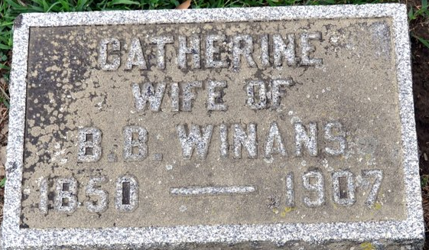
Photo by Deb Curry
Catherine Arthur Winaus
in the Indiana, U.S., Death Certificates, 1899-2017
Name Catherine Archer Winans
[Catherine Archer]
Gender Female
Race White
Marital Status Married
Age 57
Birth Date 20 Oct 1850
Birth Place Indiana
Death Date 28 Dec 1907
Death Place Pleasant, Adams, Indiana, USA
Death Registration Date 1907
Father Aron Archer
Mother Harrison
Spouse Ben Winans
Informant Ben Winans; Pleasant Mills, Indiana
Burial December 29, 1907; Decatur Cemetery

