Benjamin Britton Winans
April 12, 1849 – April 1, 1925

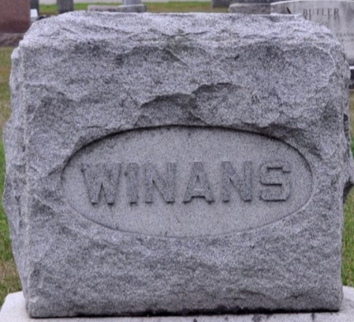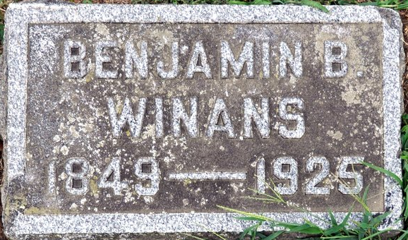
Photo by Deb Curry
Benjamin B. Winans, 75, died yesterday afternoon at 3 o'clock at the home of his son, Charles Winans, east of this city on the Maysville Road. Mr. Winans was a Civil War veteran, enlisting when he was 15 years of age in Company M of the Fourth Pennsylvania Calvary.
He is survived by five sons and one daughter: Benjamin A., Livingston, Mont.; Herbert, Springfield, O.; Kenneth, Piqua, O.; Frank, Petoskey, Mich.; Charles, at whose home his died, and Mrs. Mabel Ortiz, Cleveland, O.; three brothers, 23 (or 25) grandchildren and 13 great grandchildren.
The body was removed to the Klaehn & Sons Parlors and funeral announcement will be made later.

Journal Gazette, Allen Co, Indiana
April 2, 1925

**
Former Decatur Resident Died at Ft. Wayne Yesterday
B. B. Winans, age 75, former Decatur and Adams County resident, died at the home of a brother...
Wayne at 3 o'clock Wednesday after] noon. He had been ill... weeks, suffering with... of diseases. He was b[orn]... in Adams County and r... til about five years ago... several years ago. He f... five sons and one daughter... Winans, of this city, ...
Funeral service will be... from an undertaking parlor in Fort Wayne at 1 o'clock Friday afternoon. The body will be brought to this city for burial in the Decatur Cemetery. The funeral party is due to arrive here about 2:30 o'clock.

Decatur Daily Democrat, Adams County, Indiana
April 2, 1925

Note: There is a scrap of paper covering part of the article that is in the filmed copy and cannot be removed

**
Indiana, U.S., Death Certificates, 1899-2011
Name: Benjamin B. Winans
Gender: Male
Race: White
Age: 75
Marital status: Widowed
Birth Date: 12 Apr 1849
Birth Place: Adams County. Ind
Death Date: 1 Apr 1925
Death Place: Adams, Allen, Indiana, USA
Father: Joseph Winans
Mother: Nancy Heath
Spouse: Catherine
Informant: Charles Winans; Fort Wayne, Indiana
Burial: April 3, 1925; Decatur, Indiana

