Albert D. Winans
January 6, 1883 – December 1, 1947

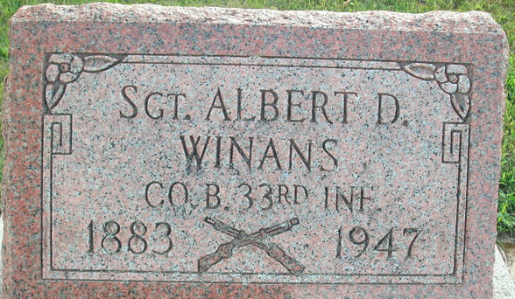
Photo by Deb Curry
Albert D Winans
in the Indiana, U.S., Death Certificates, 1899-2017
Name Albert D Winans
Gender Male
Race White
Marital Status Single
Age 64
Birth Date 6 Jan 1883
Birth Place Pleasant Mills, Indiana
Death Date 1 Dec 1947
Death Place Decatur, Adams, Indiana, USA
Death Registration Date 1947
Father Joseph F Winans
Mother Ella McCollough
Informant Mrs. Jess Niblick; Decatur, Indiana
Burial December 3, 1947; Decatur Cemetery; Decatur, Indiana

