Thomas A. Wilson
June 18, 1965 – June 18, 1965

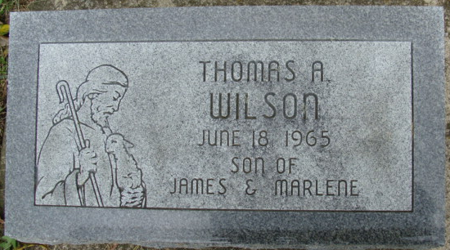
Photo by Alicia Kneuss

Thomas Wilson from tree Krückeberg Bleeke Peppler Behrman Vollmer Albersmeier Tree
Birth 1965
Death 1965
No publicly available family members
[Parents: James Wilson and Marlene Thieme]

