James Craig Wilson
March 20, 1823 – November 29, 1866

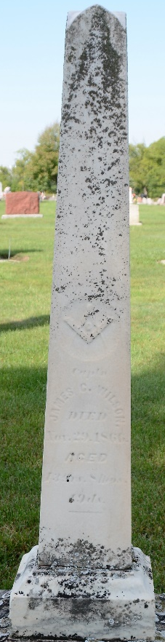
Photo by Deb Curry

From Maplewood burials, Decatur library:

Wilson, James C., died November 29, 1866, age 43 yrs, 9 mo, 19 da.
32 (degree) Mason.

**
James Craig Wilson from tree Family tree's from Ohio and Indiana

Birth 20 Mar 1823 Ireland
Marriage 29 Dec 1847 Allen, Indiana, USA
Residence 1 Jul 1863 Allen, Indiana, USA
Death 29 Nov 1866 Decatur, Adams, Indiana, USA
Spouse Elizabeth J Porter (1830-1888)

