Donnie R. Wills
December 21, 1943 – April 9, 2007

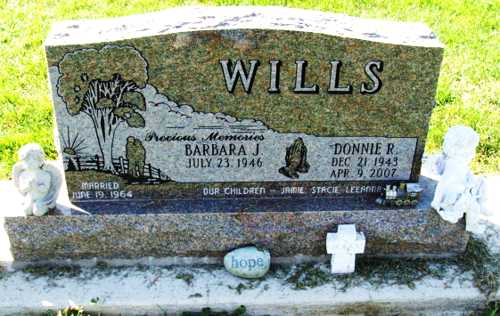
Photo by Alicia Kneuss

Donnie R. Wills, 63, Decatur, father of a Pennville resident, died Monday in Hospice Home in Fort Wayne. A native of Springport, he was a retired inspector with Borg Warner Automotive in Muncie.
Surviving are his wife, Barbara; one son, Jamie R. Wills, Pennville; two daughters; two sisters; nine grandchildren; and one great-grandchild.
Services are set for 2 p.m. Thursday in the Haggard and Sefton Funeral Home, Decatur, with Pastor Paul Baty, Pastor Dan York and Stacie Chambers officiating. Burial will be in the Decatur Cemetery. Friends may call at the funeral home from 5 to 8 p.m. today and from noon until time of services Thursday.
Memorials may be made to Hospice Home or Erin's House.

Commercial Review, The (Jay County, Indiana)
Thursday, April 12, 2007
**

Donnie R. Wills, 63 of Decatur, passed away Monday, April 9, 2007 at the Hospice Home in Fort Wayne, IN. Donnie was born on December 21, 1943 in Springport, Indiana to the late Raymond & Olive (Jones) Wills. He married Barbara Montgomery on June 19, 1964. She survives.
Surviving family is a son Jamie R. (Debbie) Wills of Pennville, IN., 2 daughters Mrs. Scott (Stacie J.) Chambers of Elkhart, IN., Mrs. Fred (Leeanna J.) Fuelling of Decatur; 2 sisters Shirley Curtis of Anderson, Nancy Wright of Ann Arbor, MI; 9 grandchildren and 1 great grandchild. Preceded Donnie is death is also a brother.
Donnie attended Grace Fellowship in Decatur. He retired from Borg Warner Automotive in Muncie as an inspector.
Calling hours are from 5-8 pm Wednesday, April 11, 2007 and noon - 2:00 pm Thursday, April 12 at Haggard & Sefton Funeral Home. Funeral services will be held at 2:00 pm Thursday, April 12, 2007 at the funeral home. Officiating will be Pastor Paul Baty, Pastor Dan York and Stacie Chambers. Burial is in Decatur Cemetery. Memorials are to Hospice Home or Erin's House.

Haggard - Sefton & Hirschy Funeral Home, Adams County, Indiana
**

Indiana, U.S., Death Certificates, 1899-2017

Name Donnie R Wills
Gender Male
Race Caucasian (White)
Marital Status Married
Age 63
Birth Date 21 Dec 1943
Birth Place Springport, Indiana
Death Date 9 Apr 2007
Death Place Fort Wayne, Allen, Indiana, USA
Death Registration Date 2007
Father Raymond Wills
Mother Olive Jones
Spouse Barbara Montgomery
Informant Barbara Wills; spouse; Decatur, Indiana
Burial April 12, 2007; Decatur Cemetery; Decatur, Indiana

