Nile Lamont Williamson
September 18, 1925 – May 26, 2009

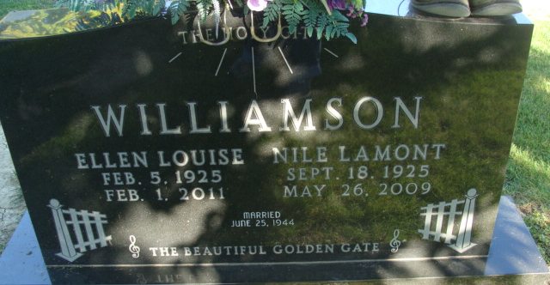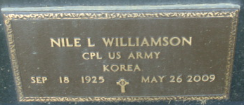
Photo by Alicia Kneuss
Nile L. Williamson, 83 years old of Decatur, Indiana, passed away on Tuesday, May 26, 2009 in the Woodcrest Nursing Center. He was born on Friday, September 18, 1925 in Wells County, Indiana the son of the late Lawrence Williamson and the late Glenn Irene (Grover) Williamson. He married Ellen L. Draper on June 25, 1944 in Union Chapel United Methodist Church.
Nile served in the United States Army during the Korean Conflict. He was a member of Union Chapel United Methodist Church and the Supervisors Club of Fort Wayne.
He retired in September 1990 from Indiana - Michigan Power as a supervisor lineman.
Surviving are his wife, Ellen L. Williamson of Decatur, Indiana.
Preceding Nile in death were three brothers; Dorris, DeWitt, & Eugene Williamson and two sisters; Veda and Frieda Williamson.
Funeral services will be held at 1:30 p.m. Saturday, May 30, 2009 in the Zwick & Jahn Funeral Home with Pastor Ed Karges officiating. Interment will follow in the Decatur Cemetery. Friends will be received from 11:30 a.m. until the time of service on Saturday in the funeral home.
Preferred memorials are to Parkinson's Foundation or Union Chapel United Methodist Church.
Zwick & Jahn Funeral Home, Adams County, Indiana
May 27, 2009

