Marcile (Myers) Williamson
August 30, 1917 – March 25, 1995

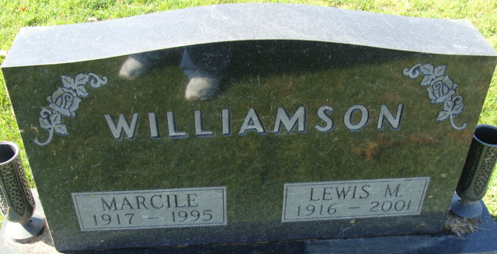
Photo by Alicia Kneuss
Marcile Williamson, 77, of Decatur died Saturday in Adams County Memorial Hospital. The Adams County native retired from Schmitt Packing Co, after working as a secretary there.
Surviving are her husband, Lewis; her mother, Minnie Foreman Myers of Decatur; daughters, Shirley Wolfe and Judy Brenner, both of Decatur; brothers, Donald Myers of Constantine, Mich., Loren Myers of Monroe, and Larry Myers of Decatur; sisters, Faye Miller of Decatur and Dorothy Brown of Fort Wayne; six grandchildren; 18 great-grandchildren; and one step great-grandchild.
Services are 11 a.m. tomorrow in Haggard & Armes Funeral Home, Decatur, where calling is 2 to 5 and 7 to 9 p.m. today and 9 to 11 a.m. tomorrow. Burial will be in Decatur Cemetery.
Preferred memorials are gifts to Allen Home Health Care or the American Lung Association.
News-Sentinel, Allen County, Indiana
Monday, March 27, 1995
**
Indiana, U.S., Death Certificates, 1899-2017
Name Marcile Williamson [Marcile Myers]
Gender Female
Race White
Marital Status Married
Age 77
Birth Date 30 Aug 1917; Birth Place Adams County, Indiana
Death Date 25 Mar 1995; Death Place Decatur, Adams, Indiana, USA
Father Frank Myers
Mother Minnie Foreman Myers
Spouse Lewis Williamson
Informant Lewis Williamson; husband; Decatur, Indiana
Burial March 28, 1995; Decatur Cemetery; Decatur, Indiana

