Jerry D. Williamson
October 11, 1939 – October 1, 2018

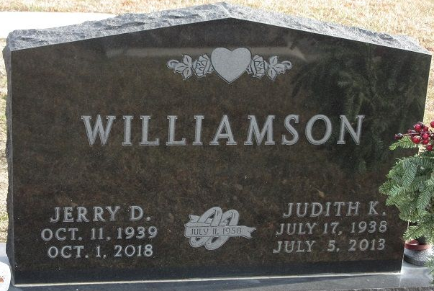
Photo by PLS
Jerry D. Williamson, 78, of Decatur, IN, passed away at his residence on Monday, October 1, 2018. He was born in Adams County, IN, on October 11, 1939, the son of the late Earl N. and Helen M. (Brown) Williamson. On July 11, 1958, he married Judy K. Keller and after 55 years together she preceded him in death on July 5, 2013.
He worked as a toolmaker for Zollner Corp for 40 years. Upon his retirement he delivered vehicles for several years for Courtesy Motors and Custom Car Care. He was a member of the Moose Lodge 1311 and the Sons of the American Legion Post 43.
Jerry is survived by a son, Greg (Lori) Williamson of Decatur; 2 daughters, Dawn (Roger) Allison of Ossian and Julie Sheehan of Decatur; 5 grandchildren, Danelle (Andrew) Taylor, Tyler Williamson, Nicole (Lyndon) Thieme, Nathan (Erika) Allison, and Clayton Sheehan and 2 step great grandchildren.
He was preceded in death by 2 brothers, Gene & Norman “Butch” Williamson and a sister, Cheryll Eyanson.
Visitation will be from 2:00 – 8:00 p.m. on Friday, October 5, 2018 at Haggard-Sefton-Hirschy & Zelt Funeral Home. A Funeral Service will be held at 11:00 a.m. on Saturday, October 6, 2018 at Haggard-Sefton-Hirschy & Zelt Funeral Home, with visitation 1 hour prior from 10:00 – 11:00 a.m. Officiating will be Pastor Dave Taylor and burial will take place in the Decatur Cemetery.

Haggard & Sefton Funeral Home, Adams County, Indiana
October 2, 2018

