Ruth S. (Deam) Williams
July 29, 1890 – August 30, 1967

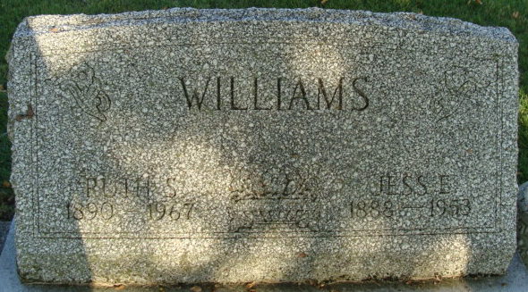
Photo by Alicia Kneuss

Ruth S. Williams is Taken by Death
Mrs. Ruth S. Williams, 77, of this city, a lifelong resident of Adams County, died at 5 p.m. Wednesday at the Berne Nursing Home following an illness of several years.
She was born in Adams County July 29, 1890, a daughter of Mr. and Mrs. Adam Deam, and was married to Jesse E. Williams May 4, 1911. Her husband preceded her in death June 8, 1935 (sic; 1953).
Mrs. Williams was a member of the Decatur Evangelical United Brethren Church and the Missionary Society of the church. She was an employee of the Schafer Glove Co. from 1942 until retiring in 1955.
Surviving are four daughters, Mrs. Orval (Melvena) Reed and Mrs. Gregg (Helen) Zimmerman, both of Decatur, Mrs. Layke (Sally) Scherry of Bluffton, and Mrs. Marion (Hilda) Jackson of Sarasota, Fla.; two sons, Donald Williams of Decatur, and Darrell Williams of Monroe; two sisters, Mrs. Bertha Hakey of Decatur, and Mrs. Mabel Booher of Sturgis, Mich. ; 14 grandchildren and nine great-grandchildren.
Funeral services will be conducted at 1:30 p.m. Saturday at the Zwick Funeral Home, with Rev. Fuhrman Miller officiating. Burial will be in the Decatur Cemetery. Friends may call at the funeral home after 7 p.m. today until time of the services.

Decatur Daily Democrat, Adams Co, Indiana
Thursday, August 31, 1967

