Ruth B. (Baltzell) Williams
January 3, 1893 – September 4, 1962

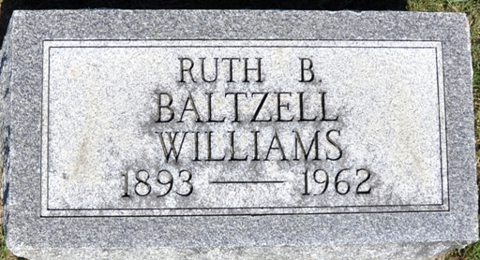
Photo by Deb Curry
Indiana, U.S., Death Certificates, 1899-2017
Name Ruth B Williams [Ruth B Baltzell]
Gender Female; Race White
Marital Status Divorced
Age 69
Birth Date 3 Jan 1893
Birth Place Adams County, Indiana
Death Date 4 Sep 1962
Death Place Rural, Wayne, Indiana, USA
Father John Baltzell [sic]
Mother Rebecca Ruby [sic]
Informant Richmond State Hospital; Wayne County, Indiana
Burial September 5, 1962; Decatur Cemetery; Decatur, Indiana

**
Collection: Indiana, Marriages, 1811-1959
Groom: Harry Otis Williams
Groom's Race: White; Groom's Residence: Indianapolis, , Indiana
Groom's Date of Birth: 23 Apr 1892; Place of Birth: , Adams, Indiana
Groom's Number of Marriage: 1st
Groom's Father: Lemuel Grant/Len Williams
Groom's Mother: Elizabeth E Hawkins/Hawkin
Bride: Ruth Belle Baltzell
Bride's Race: White; Bride's Residence: Decatur, , Indiana
Bride's Date of Birth: 03 Jan 1893; Bride's Place of Birth: , Adams, Indiana Bride's Number of Marriage: 1st
Bride's Father: Thomas/F. H. Baltzell
Bride's Mother: Emma Jane Andrews
Date of License: 16 Jun 1915
Date of Marriage: 16 Jun 1915; Place of Marriage: Decatur, Adams, Indiana
Record Number: 671; GSU Film Number: 2321468; Digital GS Number: 4186023; Digital Image Number: 00623; Number of Images: 1
Record Number: 4784; GSU Film Number: 2321469; Digital GS Number: 4186024; Digital Image Number: 00325; Number of Images: 1

