Mary Elizabeth (Hinkle) Williams
June 17, 1848 – October 24, 1928

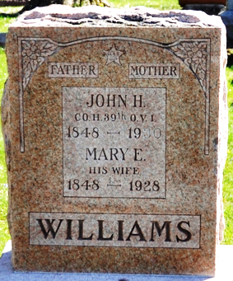
Photo by Deb Curry
Mary Elizabeth Williams
in the Indiana, U.S., Death Certificates, 1899-2017
Name Mary Elizabeth Williams
[Mary Elizabeth Hinkle]
Gender Female
Race White
Marital Status Married
Age 80
Birth Date 17 Jun 1848
Birth Place Ohio
Death Date 24 Oct 1928
Death Place Decatur, Adams, Indiana, USA
Death Registration Date 1928
Father Henry Hinkle
Mother Mary Murphy
Spouse John Williams
Informant John H. Williams; Decatur, Indiana
Burial October 27, 1928; Decatur Cemetery

