Karlie P. Williams
November 16, 2005 – November 16, 2005

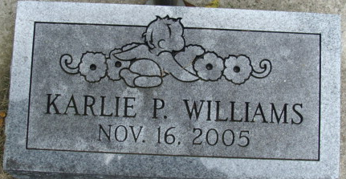
Photo by Alicia Kneuss
Karlie P. Williams, infant daughter of Mike Williams and Kelly Cochran, both of Willshire, passed away Wednesday, Nov. 16, 2005.
Journal Gazette, Allen County, Indiana
Friday, November 18, 2005
**
U.S., Cemetery and Funeral Home Collection, 1847-Current
Name Karlie P. Williams
Gender Female
Death Date 16 Nov 2005
Death Place Ft. Wayne, IN
Burial Place Decatur
Parents Mike Williams; Kelly P. Cochran
Siblings Jace Williams
**
karlie patrice williams from tree cochran Family Tree
Birth 16 Nov 2005 Fort Wayne, Allen, Indiana, USA
Death 16 Nov 2005 Fort Wayne, Allen, Indiana, USA
No publicly available family members

