Joyce D. (Mengerink) Williams
March 19, 1928 – October 14, 2003

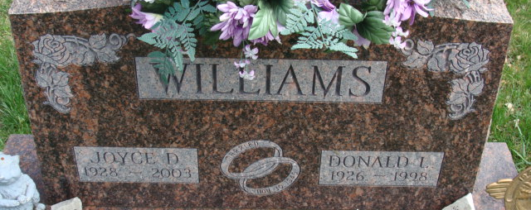
Photo by Alicia Kneuss
Joyce D Williams
in the Indiana, U.S., Death Certificates, 1899-2017
Name Joyce D Williams
[Joyce D Mengerink]
Gender Female
Race White
Marital Status Widowed
Age 75
Birth Date 19 Mar 1928
Birth Place Defiance, Ohio
Death Date 14 Oct 2003
Death Place Decatur, Adams, Indiana, USA
Death Registration Date 2003
Father Edward W Mengerink
Mother Dorothy V Mumford
Informant Barb Werst; daughter; Decatur, Indiana
Burial October 16, 2003; Decatur Cemetery; Decatur, Indiana

