John H. Williams
September 11, 1848 – April 26, 1930

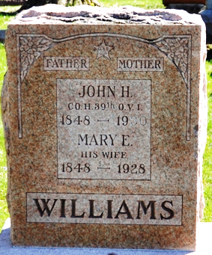
Photo by Deb Curry
John Williams
in the Indiana, U.S., Death Certificates, 1899-2017
Name John Williams
Gender Male
Race White
Marital Status Widowed
Age 81
Birth Date 11 Sep 1848
Birth Place Homes Co, Ohio
Death Date 26 Apr 1930
Death Place Jefferson, Wells, Indiana, USA
Death Registration Date 1930
Father John Williams
Mother Nancy Hinkle
Informant S. B. Ramsey; Tocsin, Indiana
Burial April 29, 1930; Decatur Cemetery

