Jesse Williams
March 3, 1832 – December 10, 1913

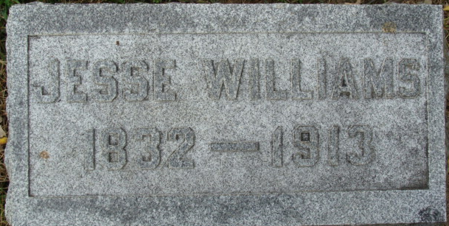
Photo by Alicia Kneuss
Jesse Williams, a veteran resident of Root Township, residing a few miles northwest of this city, died at 12:15 this noon. Mr. Williams was stricken with paralysis last Friday and during the time since then his condition has been very low, with practically no hope for recovery.
Mr. Williams was eighty-one years of age last March, since 1847.
Fort Wayne News, Allen County, Indiana
December 11, 1913
**
Indiana, U.S., Death Certificates, 1899-2017
Name Jesse Williams
Gender Male
Race White
Marital Status Married
Age 81
Birth Date 3 Mar 1832
Birth Place Pennsylvania
Death Date 10 Dec 1913
Death Place Root, Adams, Indiana, USA
Death Registration Date 1913
Father Elizah Williams
Mother [Catharine] King
Spouse Allice
Informant Mrs. Allice Williams; Decatur, Indiana
Burial December 12, 1913; Decatur Cemetery
**
JESSE WILLIAMS, farmer, owns 101 acres of land on sections 28 and 29, Root Township. He came to this county in 1847, settling in Root Township. He was born in Westmoreland County, Pennsylvania, March 3, 1832, and was fifteen or sixteen years of age when his parents came to this county. He remained with his father three years longer, when he went to Holmes County, Ohio. His father's family removed to that county when Jesse was two years old, and remained there until they came to Adams County, Indiana. The father died in 1872, in Richland County, Wisconsin, aged about sixty-eight years. He was of English ancestry. The mother, Catherine (King) Williams, was of German descent.
Our subject was married March 29, 1857, to Miss Alice Ruckman, who was born in Columbiana County, Ohio, June 16, 1838, and when she was seven years of age her parents removed to Ashland County, where she lived until she reached maturity. She was married to Mr. Williams while on a visit to a sister, Mrs. Sarah A. Long. Her father, Watson Ruckman, was born in Virginia, and died in Columbiana County, Ohio, where he went when a young man, and taught school there; he was also married in that county. His death occurred in 1859, aged about sixty years. Her mother was Hannah (Rowler) Ruckman. Both parents were consistent members of the Methodist Episcopal church.
Mr. and Mrs. Williams have had six children - William W., born February 1, 1862, lives in Decatur; Della B., born August 14, 1885, is the wife of Benjamin F. Butler; Loretta A., born May 18, 1888, is the wife of William E. Butler; Watson E., the oldest child, died in September, 1871, at the age of fourteen years, Mary E., wife of Victor V. Reed, died in August, 1880, aged twenty years, eleven months and nineteen days; Jessie Dallas, born July 20, 1874, and died January 17, 1875, she left two children; Jesse H. died in 1875, aged six years.
Mr. and Mrs. Williams commenced housekeeping at Monmouth. All their household goods were placed in a one-horse wagon. Mr. Williams worked out a week after his marriage and earned $3 with which to purchase supplies. It was in the time of wild-cat currency, and each dollar would buy only ninety cents worth. Politically Mr. Williams is a Republican. He and his wife are members of the Methodist Episcopal church.

Biographical and Historical Record - Adams and Wells Co. Indiana Lewis Publishing Co. Chicago, IL, 1887.

