Jess E. Williams
February 8, 1888 – June 8, 1953

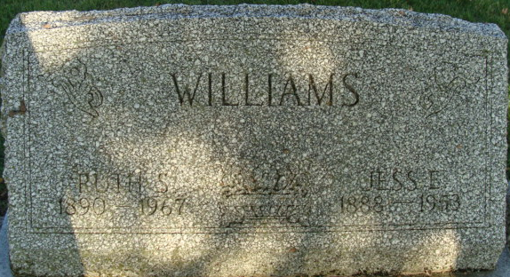
Photo by Alicia Kneuss
Jess E. Williams Dies This Morning - Funeral Services To Be Wednesday
Jess E. Williams, 65, of 209 South Ninth street, a retired mechanic, died at 5:15 o'clock this morning at the Adams County Memorial Hospital following an illness of 18 months of complications.
He was born in Adams County Feb. 8, 1888, a son of Mr. and Mrs. William Williams, and was married to Ruth Bean (sic: Deam) May 4, 1911.
Mr. Williams was a member of the Trinity Evangelical United Brethren Church.
Surviving in addition to his wife are four daughters, Mrs. Melvena Reed, Mrs. Marcell Scherry and Mrs. Helen Hanni, all of Decatur, and Mrs. Hilda Jackson of Huntington; two sons, Darrell Williams of Monroe and Donald Williams of Decatur; 13 grandchildren; two brothers, Albert and Brenton Williams, both of Decatur; and four sisters, Mrs. Marie Ault of Vicksburg, Mich., Mrs. Elsie Sprunger and Miss Myrtle Williams, both of Kalamazoo, Mich., and Mrs. Fannie Farlow of Geneva.
Funeral services will be conducted at 2 p.m. Wednesday at the Gillig & Doan funeral home, the Rev. John E. Chambers officiating. Burial will be in the Decatur Cemetery. Friends may call at the funeral home after 7 o'clock this evening until time of the services.
Decatur Daily Democrat, Adams County, Indiana
Monday, June 8, 1953
**
Indiana, U.S., Death Certificates, 1899-2017
Name Jesse E Williams
Gender Male
Race White
Marital Status Married
Age 65
Birth Date 8 Feb 1888
Birth Place Indiana
Death Date 8 Jun 1953
Death Place Decatur, Adams, Indiana, USA
Death Registration Date 1953
Father William Williams
Mother Louise Johnson
Informant Mrs. Jesse Williams; Decatur, Indiana
Burial June 10, 1953; Decatur Cemetery; Decatur, Indiana

