Donald L. Williams, Sr.
February 20, 1926 – May 20, 1998

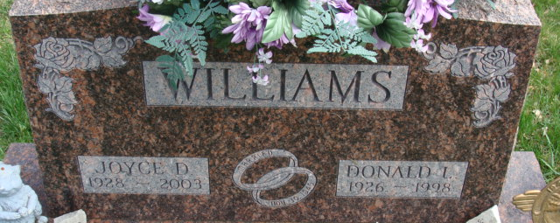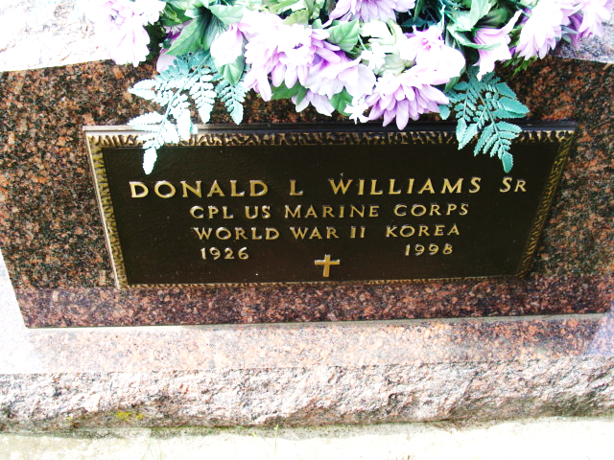
Photo by Alicia Kneuss
Donald L. Williams Sr., 72, Decatur, died suddenly at 7:41 p.m. Wednesday in the emergency room of the Adams County Memorial Hospital, shortly after arrival.
He was born on February 20, 1926 in Decatur, to Jess and Ruth Deam Williams and married Joyce Mengerink on November 30, 1946. She survives.
He was a truck driver for the Bag Service plant in Decatur and for United Oil Co. and also managed the United Oil gas station in Decatur from 1964-89. He served with the U.S. Marine Corps in the Pacific Theater during World War II.
Other survivors are two sons, Don L. Williams Jr., Fort Wayne, and Gary Williams, Decatur; three daughters, Mrs. Gary (Barb) Werst, Cindy Keen, and Sharon Clark, all of Decatur; three sisters, Mrs. Marion (Hilda) Jackson, Sarasota, Florida; Helen Zimmerman, Lubbock, Texas; and Melvina Reed, Decatur; 12 grandchildren; and three great-grandchildren.
A sister, Marcella Scherry; a brother, Darrell Williams, and a grandson are deceased.
Funeral services will be at 2 p.m. Saturday in Zwick and Jahn Funeral Home, Decatur, with burial in Decatur Cemetery, including military graveside rites by American Legion Post 43. Visiting hours are 3-7 p.m. Friday and 1-2 p.m. Saturday.
Preferred memorials are to the Adams County Heart Club or the donor's choice.
Decatur Daily Democrat, Adams County, Indiana
Thursday, May 21, 1998

