Alice (Ruckman) Williams
June 16, 1838 – February 9, 1917

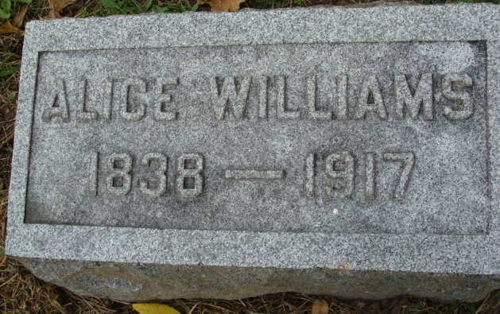
Photo by Alicia Kneuss
Died Suddenly - Mrs. Alice Williams, Widow of Jesse Williams, Passed Away - at 4:30 o'clock - at Home of Daughter, Mrs. Ben F. Butler
Ill a Half Hour
Alice Ruckman Williams, aged seventy-nine, widow of Jesse Williams, one of the well-known highly esteemed ladies of Root township, where she had been a resident for a half century or more, died suddenly this morning of heart trouble and acute indigestion, passing away at 4:30 o'clock at the home of a daughter, Mrs. Ben F. Butler.
Mrs. Williams had been in frail health for a long time, and to add to her infirmities, three weeks ago suffered a fracture of an arm in a fall. She awakened this morning about four o'clock, and at that time became very ill, passing away a half hour later.
She was born June 16, 1838, in Pennsylvania, being a daughter of Watson Ruckman. She came here in young girlhood with her parents, and was later married to Jesse Williams, who died three years ago last December. Mrs. Williams continued residing in her home near the Ben Butler home, for a while but last fall went to make her home with her daughter.
Mrs. Williams, who was the last of her parental family, leaves two children.
Besides the daughter, Mrs. Butler, has a son, William Williams, of this city.
The funeral will be held Monday afternoon at one o'clock from the Butler home. Burial will be in the Decatur Cemetery.
Decatur Daily Democrat, Adams County, Indiana
Friday, February 9, 1917
**
Indiana, U.S., Death Certificates, 1899-2017
Name Alice Williams
[Alice Ruckman]
Gender Female
Race White
Age 78
Birth Date 16 Jun 1838
Birth Place Pennsylvania
Death Date 9 Feb 1917
Death Place Root, Adams, Indiana, USA
Death Registration Date 1917
Father Wattson Ruckman
Mother Unknown [Hannah Rowler]
Spouse Jesse Williams
Informant B. F. Butler; Decatur, Indiana
Burial February 12, 1917; Decatur Cemetery

