Nyla M. (Morningstar) Wilkinson-Wiehe
May 29, 1927 – June 8, 2011

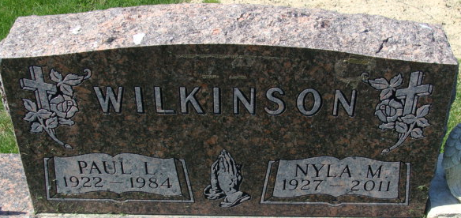
Photo by Alicia Kneuss
Nyla M. Wiehe, 84 years old of Decatur, Indiana, passed away on Wednesday, June 8, 2011 in the Village of Heritage located in Monroeville.
She was born on Thursday, May 29, 1927 in Adams County, Indiana the daughter of the late John F. Morningstar and the late Effie J. (Teeter) Morningstar. She married Paul L. Wilkinson on March 22, 1952 and he passed away on February 4, 1984. On August 7, 1994 she married Edward L. Wiehe in Decatur, Indiana and he survives.
Nyla was a member of Decatur Church of Christ where she was the pianist for over 30 years. She was also a member of General Electric Retirees, O.N.O. Club, American Legion Auxiliary Post #43 and a previous member of the Decatur Moose Lodge.
She was employed at General Electric in Decatur for forty-one years.
Surviving are her husband, Edward L. Wiehe of Decatur, son, Gregory L. Wilkinson of Elkhart, daughter, Paula N. Hutchinson of Elkhart, son, Leslie G. (Marla) Wilkinson of Elkhart, step-daughter, Patsy Jo (Bruce) Myers of Monroeville, step-son, Byron K. (Karen) Wiehe of Sorrento, Florida, step-son, Gregory M. (Melissa) Wiehe of Grabill, step-son, Glen (Oralia) Wiehe of Conroe, Texas, brother, Virgil (Agnes) Morningstar of Fort Wayne, sister, Virginia Ruth (Claude) Foreman of Ossian, four grandchildren, three great-grandchildren, eight step-grandchildren and eight step great-grandchildren.
Preceding Nyla in death were three brothers; Theodore, Chester & Gerald Morningstar and three sisters; Mildred Schindler, Augusta Butcher & Dorotha Morningstar.
Funeral services will be held at 11:00 a.m. Saturday, June 11, 2011 in the Zwick & Jahn Funeral Home with Rev. Gary Johnson and Rev. David Rea officiating. Interment will follow in the Decatur Cemetery. Friends will be received from 2 to 5 & 6 to 8 p.m. Friday in the Zwick & Jahn Funeral Home, Decatur and one hour prior to the funeral service on Saturday at the funeral home.
Preferred memorials are to Decatur Church of Christ, The Village of Heritage, or Family Hospice and Palliative Care in Berne, Indiana.

Zwick & Jahn Funeral Home, Adams County, Indiana
June 9, 2011

