Joan Wilkinson
1925 - 1925

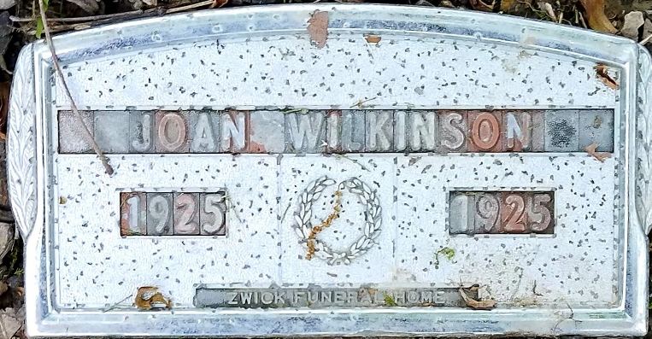
Photo by Alicia Kneuss

No further information found at this time

