Bernice (Burger) Wilkinson
July 25, 1900 – August 27, 1929

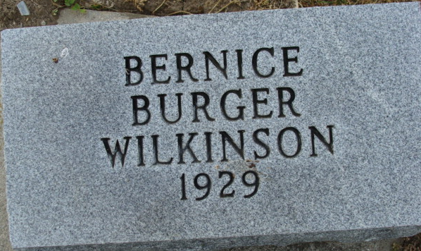
Photo by Alicia Kneuss

Indiana, U.S., Death Certificates, 1899-2017
Name Berneice Wilkinson
[Bernice Berger]
Gender Female
Race White
Marital Status Widowed
Age 29y 7m 3d
Birth Date 25 Jul 1900
Birth Place Indiana
Death Date 27 Aug 1929
Death Place Decatur, Adams, Indiana, USA
Death Registration Date 1929
Father David Berger
Mother Dara Reynolds
Informant M or W Wilkinson
Burial Decatur Cem Aug 30, 1929

