Vivian Cleona (Hitchcock) Wilhoit
August 22, 1922 – February 25, 1965

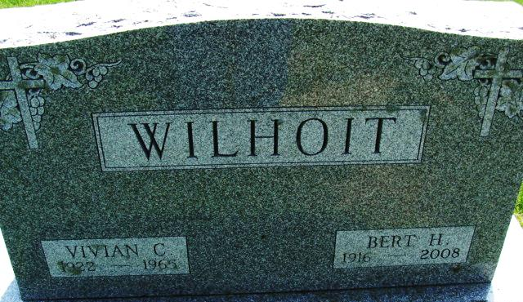
Photo by Alicia Kneuss

Vivian Cleona Hitchcock Wilhoit
in the South Carolina, U.S., Death Records, 1821-1972
Name Vivian Cleona Hitchcock Wilhoit
[Vivian Cleona Hitchcock Hitchcock]
Gender Female
Race White
Age 42
Birth Date 22 Aug 1922
Birth Place Ohio
Death Date 25 Feb 1965
Death Place Greenville, South Carolina, USA
Death Registration Place South Carolina, USA
Father Charles W Hitchcock
Mother Fannie Green
Informant Bert Harvey Wilhoit
Removal February 25, 1965; Maplewood Cemetery; Decatur, Indiana

