Henrietta (Bohnke) Wilder
December 21, 1879 – October 9, 1947

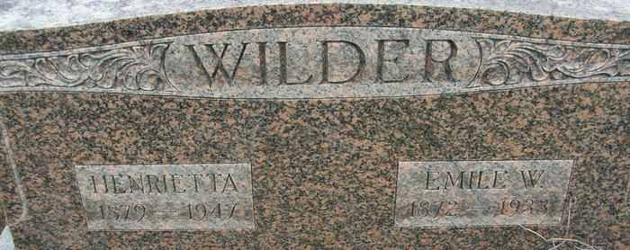

Mrs Henrietta Wilder
in the Indiana, U.S., Death Certificates, 1899-2017
Name Mrs Henrietta Wilder
[Mrs Henrietta Bohnke]
Gender Female
Race White
Marital Status Married
Age 77
Birth Date 21 Dec 1869 (sic)
Birth Place Root Twp Adams Co Indiana
Death Date 9 Oct 1947
Death Place Rural, Adams, Indiana, USA
Death Registration Date 1947
Father Fred Bohnke
Mother Wilhelmina
Spouse Emil W Wilder
Informant Arthur Wilder; Decatur, Indiana
Burial October 13, 1947; Decatur Cemetery; Decatur, Indiana

