Emile W. Wilder
January 31, 1872 – August 1, 1933

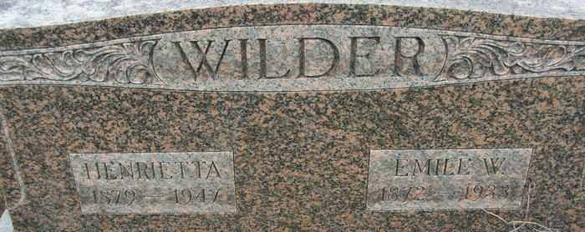

EMIL W. WILDER DIES TUESDAY
Adams County Farmer Dies Early Today After Long Illness
Emil W. Wilder, 61, farmer, residing three miles south of this city, died at his home from complications Tuesday morning at 3:15 o’clock, following an illness of four years. The deceased was born in Root Township, January 31, 1872. a son of Mr. and Mrs. Edmund Wilder. He was united in marriage to Henrietta Bohnke on March 2, 1901.
Surviving, besides the widow, are a son, Arthur, at home and two grandchildren, Arthur. Jr., and James Earl.
Funeral services will be held Thursday afternoon at 2 o'clock, standard time, at the home, three miles south of Decatur, and burial will be made in the Decatur Cemetery. Rev. David Grether will officiate at the funeral services. Mr. Wilder was a member of the Concord Church. The body was taken to the W. H. Zwick and Sons Funeral Home and will be removed to the Wilder home late this afternoon.
Decatur Daily Democrat; Adams County, Indiana
Tuesday, August 1, 1933
**
Emile W. Wilder from tree David Shank Family Tree-04062012_2013-11-20
Birth Jan 1872 Indiana, USA
Marriage 2 Mar 1901 Indiana, USA
Residence 19 Apr 1930 Adams, Indiana, USA
Death 1933
Father Edmund Wilder (1826-1889)
Mother Sarah J. Thompson (1846-1908)
Spouse Henrietta Bohnke (1869-1947)

