Dwight Wilder
July 31, 1865 – July 6, 1915

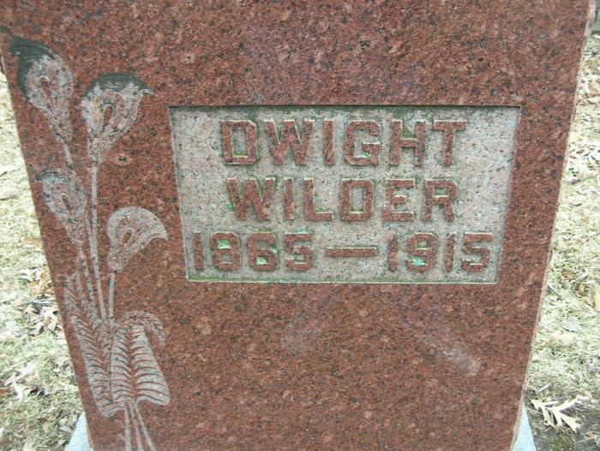

DECATUR NEWS (Special Correspondence)
Dwight Wilder, a well-known farmer residing north of this city, died suddenly last night at 9 o'clock from either a stroke of apoplexy or cerebral hemorrhage, his death causing quite a shock to the community where he had lived practically all his life.
Mr. Wilder was apparently in the best of health yesterday, having done a heavy day's work in the harvest field and was returning from his chores when he suddenly became blind. Mrs. Wilder hurried to a neighbor for assistance, but within a few moments after a physician reached the home, Mr. Wilder expired.
The deceased was 50 years old and leaves a wife and one son to mourn his loss.
The funeral will be held Friday afternoon from the M. E. Church in this city.
Fort Wayne News, Allen County, Indiana
July 7, 1915
**
Decatur, Ind. - July 7 – Dwight Wilder, 45 (sic) died suddenly last night at his farm home in Root Township of apoplexy. He had been in apparently good health and had worked about the farm as usual yesterday.
He leaves a widow and one son, Ralph. The widow was formerly Miss Cora Krill. A brother, Emile, and a sister, Belle, wife of Burt Dietelbach, of Findlay, Ohio are living. He was a son of Edmund Wilder, one of the pioneers of this township.
Fort Wayne Weekly Sentinel, Allen County, Indiana
July 14, 1915
**
Decatur, In. - July 8 – The funeral of Dwight Wilder will be held Friday afternoon at 1:30 o'clock at the Decatur Methodist Church, the Rev. A. K. Mumma, of the Concord Church, officiating.
Fort Wayne Weekly Sentinel, Allen County, Indiana
July 14, 1915
**
Indiana, U.S., Death Certificates, 1899-2017
Name Dwight Wilder
Gender Male
Race White
Marital Status Married
Age 49
Birth Date 31 Jul 1865
Birth Place Adams County, Indiana
Death Date 6 Jul 1915
Death Place Root, Adams, Indiana, USA
Death Registration Date 1910-1919
Father Adinan Wilder
Mother Sarah Thompson
Spouse Cora
Informant Emil Wilder; Decatur Cemetery
Burial July 9, 1915; Decatur Cemetery

