Chauncey C. Wilder
January 5, 1861 – December 15, 1916

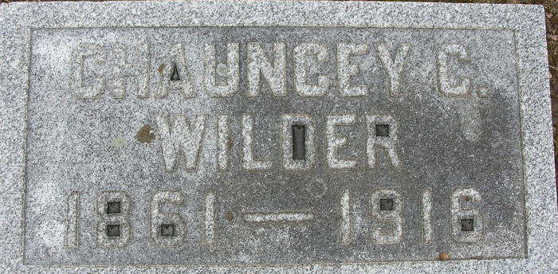

PROVED FATAL
C. C. Wilder Passed Away Early This Morning at Lutheran Hospital
IN FORT WAYNE
Ill Short Time - Fifty-five Years Old - Native of Root Township
Chauncy C. Wilder, of Monmouth, aged fifty-five years, for twenty-six years in business in this city, passed away this morning at 5:30 o'clock at the Lutheran Hospital, Fort Wayne, where he was taken yesterday morning at eight o'clock, undergoing an operation a few hours later for the removal of the gall bladder and gall stones.
Mr. Wilder, who was an unusually strong and robust-looking man, became ill only last Sunday, with what at the time was supposed to be an attack of acute indigestion. He suffered most severely at times, and yesterday morning, when efforts failed to relieve him, he was taken to the hospital for examination. An operation was decided upon and it was found that the gall bladder was in a gangrene condition. This was removed, together with eight gall stones.
The seriousness of his condition became apparent at once, however, and very little hope was extended for his recovery, from that time.
The news of his death, however, comes very unexpectedly to his many friends, as he had been at his post as manager of the West Monroe Street meat market, up until last Saturday night, when he seemed to be in his usual good health. He was particularly well liked for his jovial disposition, and his friends were innumerable.
Mr. Wilder was the youngest son of Edwin and Mary Barkley Wilder. He was born on the Wilder farm, known as "The North Place" in Root Township, January 5, 1861, and had he lived until next January fifth, would have been fifty-six years of age.
Except for a short residence in his youth in Fort Wayne, three years in the U. S. standing Army in the west, and a short residence in this city, he has made his home in Monmouth, purchasing and making as his home, the old Wilder homestead, at Monmouth.
He is survived by the wife, who was formerly Miss Winnie Watts, a daughter of the late Rev. Watts, and six daughters. They are: Annice, wife of George Simmers, this city; Harriet, wife of Fred Nye, Monmouth; Bessie, Myrtle, Jessie Doris and Edwinna.
Mr. Wilder is the last of a family of three, two sisters, Ellen, wife of D. V. Steele, and Harriet, wife of Jacob J. Manley, having preceded him in death.
Mr. Wilder was engaged in the butcher business in this city for the last twenty-six years, having been in business for himself for many years, and later being a stockholder in the Hoosier Packing Company, being the manager of one of the shops owned by this company.
The body was brought to the home in Monmouth at noon today. Funeral services will be held from the home at ten o'clock Monday morning. The Rev. Shank, of Hoagland, pastor of the Concord English Lutheran Church, of which the deceased was a member, will officiate. Burial will be in the Decatur Cemetery.
Decatur Daily Democrat; Adams County, Indiana
Friday, December 15, 1916

