Donald G. Weitfeldt
July 19, 1942 – March 4, 2021

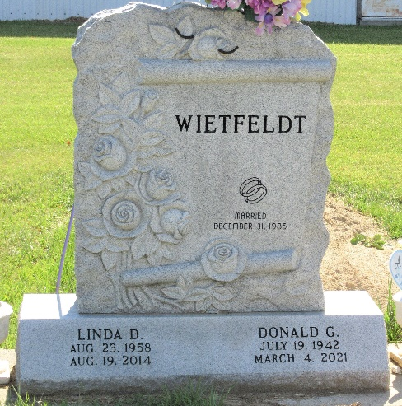
Photo by PLS
Donald G. Wietfeldt, 78, of Monroe, Indiana passed away Thursday, March 4, 2021, at St. Rita’s Medical Center in Lima, Ohio. He was born on July 19, 1942, in Decatur, Indiana to the late Oscar Wietfeldt and the late Elizabeth (Patterson) Wietfeldt. Don was united in marriage to Linda D. Hale on December 31, 1985, in Van Wert, Ohio and she preceded him in death on August 19, 2014.
He was a member of the Eagles Aerie #2653 and the Sons of the VFW #6236.
Don retired from Prestress Services following over 35 years of service. In addition, Don and Linda were the owner and operators of D & L Escorts as Flag Car Drivers. He enjoyed fishing and woodworking. Don loved a good hog roast and the pleasure that came with spending time with family and friends at them.
Survivors include five sons, Bryan (Fawn) Wietfeldt, Donald (Jody) Wietfeldt, David (Onetta) Wietfeldt, Roger (Jennifer) Hale, and Scott (Janet) Fox all of Decatur, Indiana; four daughters, Laura (Jeff) Shaffer of Decatur, Indiana, Sandra (Joe) Thomas of Middlebury, Ohio; Kristine (Tony) Peterson of Decatur, Indiana, and Melinda Arnold of Decatur, Indiana; 32 grandchildren; 42 great-grandchildren; sister, Sharon (Burl) Scott of Ceylon, Indiana; and his dog Babe.
He was preceded in death by a son, Edward Wietfeldt; a grandson, Daniel Smith; and a great-granddaughter, Natalie Roll.
A funeral service for Don will be held at 10:30 a.m. Tuesday, March 9, 2021, at the Zwick & Jahn Funeral Home - Decatur with Life Celebrant Molly Farthing officiating. Following the graveside service at Decatur Cemetery, a Celebration of Life will be continued for Don at the Eagles Lodge #2653 in Decatur. Friends and family will be received from 5-8 p.m. Monday, March 8, 2021, at the Zwick & Jahn Funeral Home in Decatur.
In lieu of flowers the family is requesting that preferred memorials be made to the family. Checks can be made out to Zwick & Jahn Funeral Home in Decatur, Indiana.
Zwick & Jahn Funeral Home, Adams County, Indiana
March 5, 2021

