Mabel V. (Lehrman) Wiegmann
August 13, 1909 – December 17, 2005

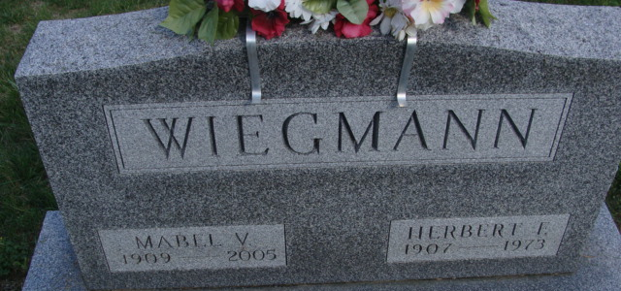
Photo by Alicia Kneuss
Mabel V. Wiegmann, 96, of Decatur, died Saturday, Dec. 17, 2005, at Adams Memorial Hospital. Born Aug. 13, 1909, in Allen County, Ind., she was the daughter of Carl and Martha (Boknecht) Lehrman. She married Herbert F. Wiegmann on Feb. 11, 1934, and he died on Dec. 11, 1973.
She retired from Wayne Novelty, Decatur, in 1970 and was a member of Lutheran Women's Missionary Society, Adams County Senior Citizens and Zion Lutheran Church, Decatur.
Survived by daughters, Ruth Ann (Jim) Price of Decatur and Carolyn (William Ellison) Sappenfield of Fort Wayne; four grandchildren; and six great-grandchildren. She was preceded in death by her brother, Clarence Lehrman; and sister, Lydia Lehrman.
Service is 11 a.m. Wednesday at Haggard & Sefton Funeral Home, Decatur, with calling one hour prior to service. Pastor Scott Bruick officiating. Calling is also from 2 to 4 and 6 to 8 p.m. Tuesday at the funeral home. Burial at Decatur Cemetery, Decatur.
Memorials to Zion Lutheran Church, Lutheran Hour, Adams Memorial Hospital or Miller Arnold Relief Fund.

News-Sentinel, Allen County, Indiana
Sunday, December 18, 2005

