Herbert F. Wiegmann
May 22, 1907 – December 11, 1973

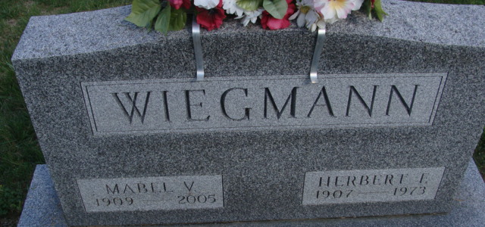
Photo by Alicia Kneuss
Herbert Wiegmann Dies This Morning
Herbert F. Wiegmann, 66, of route 5, Decatur, a farmer and former school bus driver, died at 7:25 a.m. today at the Adams County Memorial Hospital, where he had been a patient since Sunday.
Mr. Wiegmann was a member of the Immanuel Lutheran Church. He was a school bus driver from 1955 to 1968.
Born in Madison Township, Allen County, on May 22, 1907, he was the son of Henry and Wilhelmina Eigenberg-Wiegmann, and was married on Feb. 11, 1934, to Mabel Lehrman, who survives.
Also surviving are two children, Mrs. James (Ruth) Price of route 6, Decatur; and Mrs. Daniel (Carolyn) Sappenfield, of Fort Wayne; three sisters, Mrs. Russell (Hilda) Harding, Mrs. Glen (Amanda) Doty, and Mrs. Paul (Leona) Haenftling, all of Fort Wayne; one brother, Morris Wiegmann of route 2, Monroeville; and four grandchildren.
Funeral services will be held at 10:30 a.m. Friday at the Zwick funeral home, with Rev. O.A. Brillinger officiating. Burial will be in the Decatur cemetery. Friends may call at the funeral home after 2 p.m. Thursday.
Decatur Daily Democrat, Adams County, Indiana
Tuesday, December 11, 1973

