Shane A. Whittenbarger
August 29, 1975 – August 5, 2009

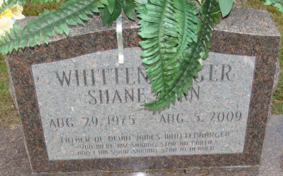
Photo by Alicia Kneuss
Shane A. Whittenbarger, 33, of Decatur, died on Wednesday evening, Aug. 5, 2009, at Latrobe Area Hospital in Latrobe, Pa. Shane was born Aug. 29, 1975, in Decatur, son of Larry C. and Norma J. (Simon) Whittenbarger.
Shane was a lifelong resident of Adams County and attended Common Ground Church. He also served in the United States Air Force and worked as a Landscaper. He was inducted into the Die Cast Hall of Fame on Feb. 19, 2009, as an Intriguing Collector.
He is survived by his parents, Larry and Norma Whittenbarger of Decatur; a son, Devin J. Whittenbarger of Scottdale, Pa.; a brother, Troy L. Whittenbarger of Decatur; two sisters, Jodi (Richard) Guntle of Decatur and Lori (Gary) Vetter of Monroe; six nephews; six nieces; and four great-nephews. He was preceded in death by grandparents, George and Florence Whittenbarger and Frank and Alma Simon.
Funeral service is 11 a.m. Saturday, Aug. 15, 2009, at Common Ground Church, with visitation one hour prior at the church. The Rev. Matt Moore officiating. Visitation also from 1 to 8 p.m. Friday, Aug. 14, 2009, at Haggard & Sefton Funeral Home in Decatur. Burial in Decatur Cemetery.
Memorials to his son, Devin's Education Fund.
News-Sentinel, Allen County, Indiana
Sunday, August 9, 2009

