Lulu (Gideon)Whittenbarger
September 20, 1870 – April 13, 1917

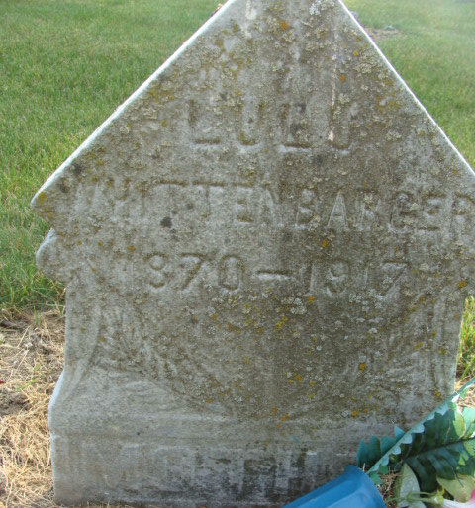
Photo by Alicia Kneuss
Lulu Whittenberger
in the Indiana, U.S., Death Certificates, 1899-2017
Name Lulu Whittenberger
[Lulu Gideon]
Maiden Name Whittenbarger
Gender Female
Race White
Marital Status Widowed
Age 46
Birth Date 20 Sep 1870
Birth Place Adams County, Indiana
Death Date 13 Apr 1917
Death Place Decatur, Adams, Indiana, USA
Death Registration Date 1917
Father John Gideon
Mother Stevens
Spouse Jonathan Whittenberger
Informant Elizabeth Burns; Decatur, Indiana
Burial April 16, 1917; Decatur Cemetery

