Larry C. “Whit” Whittenbarger
August 30, 1940 – June 24, 2016

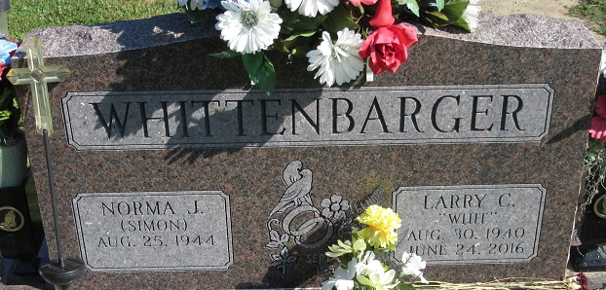
Photo by PLS
Larry C. “Whit” Whittenbarger, 75, of Decatur, IN, passed away on Friday, June 24, 2016 in the Parkview Regional Medical Center. He was born on August 30, 1940, in Decatur, IN, to the late George and Florence (Lovellette) Whittenbarger. On September 26, 1964, he married Norma Simon.
He attended The Bridge Community Church. He began working for Navistar in June of 1960 and retired after 35 years of service. He was also co-owner of the Craftshack for the last 15 years.
Larry loved to spend time with his family and friends and enjoyed fishing and riding his motorcycle.
He is survived by his wife of 51 years, Norma Whittenbarger of Decatur; a son, Troy (Amanda) Whittenbarger of Decatur; 2 daughters, Jodi (Richard) Guntle and Lori (Gary) Vetter both of Decatur; 4 sisters, Bonnie (Jerry) Knittle, Karen (Jerry) Miller, Sharon Snyder, and Janice (Ron) Swygart all of Decatur; 12 grandchildren, Brianna Whittenbarger, Drake, Byron, and Serena Guntle, Kyle & Alyssa Girod, Jessica (Chris) Wheaton, Jennafer & Jacob Vetter, Shaelyn & Hayden Whittenbarger, and Devin Whittenbarger; 7 great grandchildren, Bryce, Chance, Hagen, CJ, Ezekiel, Savaya, and Kevin.
He was preceded in death by a son Shane Whittenbarger and 2 sisters, Wanda Case and Phyllis Whittenbarger.
Visitation will be from 2:00 – 7:00 p.m. on Tuesday, June 28, 2016 at Haggard-Sefton & Hirschy Funeral Home. A Funeral Service will be held at 10:30 a.m. on Wednesday, June 29, 2016 at The Bridge Community Church, with calling 1 hour prior from 9:30 – 10:30 a.m. Officiating will be Pastor Mo Hodge and burial will take place in the Decatur Cemetery.
Memorials may be made to the A.C.C.F. Angel Cancer Fund.

Haggard & Sefton Funeral Home, Adams County, Indiana
June 25, 2016

