Florence B. (Lovellette) Whittenbarger
November 22, 1911 – December 31, 2005

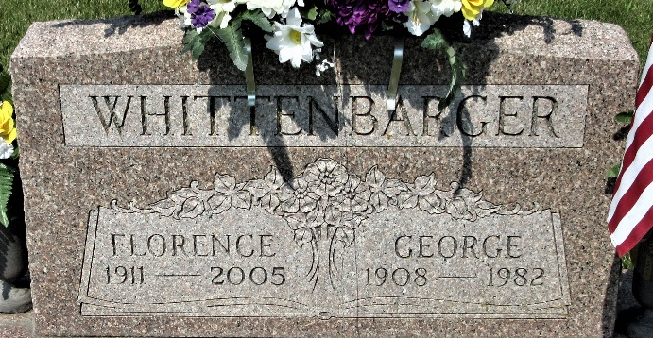
Photo by PLS
Florence B. Whittenbarger, 94, of Decatur, died Saturday, Dec. 31, 2005, at Wood-crest Nursing Center, Decatur. Born November 22, 1911, in Kingsburg, Ill., she was the daughter of the late James C. and Mary (Hedge) Lovelette. She married George C. Whittenbarger on June 14, 1930, and he died on March 16, 1982. She was a homemaker and member of Decatur Lighthouse Assembly of God, Decatur.
Survived by her son, Larry (Norma) Whittenbarger of Decatur; daughters, Bonnie (Gerald) Knittle of Decatur, Sharon Snyder of Decatur, Karen (Jerry) Miller of Decatur and Janice (Ron) Swygart of Decatur; sisters, Pearl Brubaker of Huntington and Mary Ellen Martin of Vera Cruz, Ind.; son-in-law, Rev. Max Case of Willshire, Ohio; sister-in-law, Merle Lovelette of Decatur; 24 grandchildren; 50 great-grandchildren; and 12 great-great grandchildren. She was also preceded in death by her daughters, Wanda Case and Phyllis Whittenbarger; brothers, Harry and James Lovelette; sister, Opal Peterson; and great-granddaughter, Andrea Snyder.
Service is 11 a.m. Thursday at Haggard & Sefton Funeral Home, Decatur, with calling one hour prior to service. The Rev. Raymond Bell officiating. Calling is also from 2 to 8 p.m. Wednesday at the funeral home. Burial at Decatur Cemetery.
Memorials to Decatur Lighthouse Assembly of God.

News-Sentinel, Allen County, Indiana
Monday, January 2, 2006

