Fannie M. (Carter) Whittenbarger
February 22, 1876 – June 12, 1961

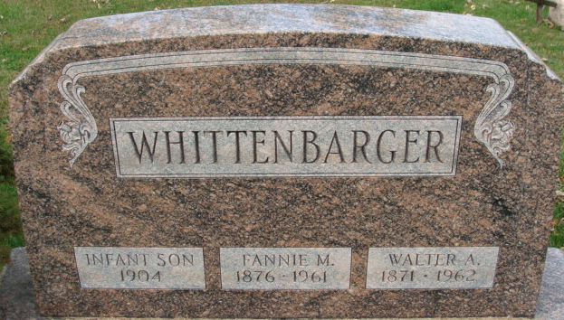
Photo by Alicia Kneuss
Decatur Lady Dies after Long Illness

Mrs. Fannie M. Whittenbarger, 85, wife of Walter A. Whittenbarger, died at 3:05 o’clock Monday afternoon at her home, 903 Walnut Street. She had been in failing health for 20 years and critically ill for the past six weeks.
Born in Harrison Township, Van Wert County, O., Feb. 22, 1876, she was a daughter of Asa and Elmira LaRue-Carter. The family moved to Decatur 18 years ago from Union Township.
Mrs. Whittenbarger was a member of the Union Chapel Evangelical United Brethren Church.
Surviving in addition to her husband are two sons, Paul L. Whittenbarger of Chatsworth, Ill., and Roy W. Whittenbarger of Fort Wayne; three grandchildren; three brothers, Richard N. Carter of Los Angeles, Calif., Sherman F. Carter of Yucaipa, Calif., and Roy W. Carter of New Post Beach, Calif., and one sister, Mrs. Bertha Mauller of Convoy, O. One son died in infancy.
Funeral services will be conducted at 2 pm Thursday at Zwick Funeral Home, the Rev. Kenneth Angie officiating. Burial will be in the Decatur Cemetery. Friends may call at the funeral home after 7 p.m. today until time of the services.

Adams County Historical Museum, Adams County, Indiana
January 1951 – August 1962 Scrapbook, image 25
Handwritten date: Tuesday June 13, 1961

