Charles Kenneth Whitted
May 29, 1925 – December 24, 2019

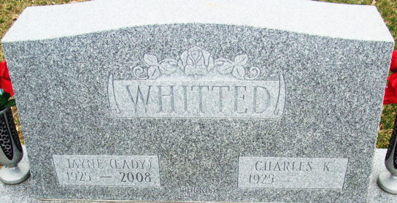
Photo by Alicia Kneuss

Charles Kenneth Whitted
in the U.S., Cemetery and Funeral Home Collection, 1847-Current
Name Charles Kenneth Whitted
Gender Male
Death Age 94
Birth Date 29 May 1925
Death Date 24 Dec 2019
Burial Place Decatur, Indiana
Obituary Date 27 Dec 2019
Parents Walter Whitted; Katherine Whitted
Child Polly J. Rushmore, Chuck, Charles K.
Siblings Carol
**
Charles Kenneth Whitted from tree Rownham Tree 2025
Birth 29 May 1925 Bedford, Lawrence, Indiana, USA
Marriage 2 Sep 1947 Allen, Indiana, USA
Residence 1950 Valparaiso, Porter, Indiana, USA
Death 24 Dec 2019 Crown Point, Lake, Indiana, USA
Father Curtis Walter Whitted (1895-1965)
Mother Catherine Lorraine Godfroy (1893-1962)
Spouse Atola Jayne Eady (1925-2008)

