Atola Jayne (Eady) Whitted
February 7, 1925 – February 3, 2008

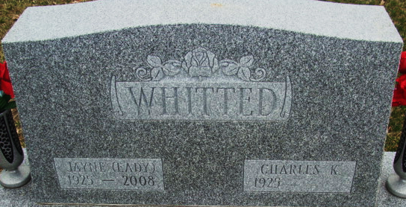
Photo by Alicia Kneuss

Jayne (nee Eady) Whitted, age 82, passed away on February 3, 2008. Jayne was born in Decatur, Indiana, the daughter of Frances & Melvina Eady. She was a graduate of Lutheran Hospital School of Nursing in Fort Wayne, IN, Class of 1945, Heidelburg College in Tiffin, OH and IUN. She was a registered nurse and worked at Porter Memorial Hospital in Valparaiso.
Jayne was a member of Eastern Starr, Huntington Lodge and Daughters of American Revolution.
She is survived by her husband of 60 years, Charles Whitted of Crown Point; 2 children: Polly (Kim) Rushmore of Lakes of the Four Seasons and Charles "Chuck" K. Whitted, Jr., of Indianapolis, IN; 5 grandchildren, Gwendolyn (Dr. Kevin) Hartzell of Crown Point, John (Erika) Rushmore of Indianapolis, Hannah (Paul) Rozeboom of Indianapolis, IN, and Benjamin Rushmore, Elizabeth Rushmore of Lakes of the Four Seasons; 2 great grandchildren, Vaughn Thomas Hartzell and Rushmore Michael Hartzell of Crown Point, IN.
Funeral Service will be held on, Wednesday, February 6, 2008 at 7:00 p.m. at Burns Funeral Home, 10101 Broadway, Crown Point, IN, with Rev. Tim Prowse officiating. Interment on Jayne's 83rd birthday, Thursday, February 7, 2008 at 1:00 p.m. EST in Decatur Cemetery, Decatur, IN. Friends may visit with the family at Burns Funeral Home on Wednesday from 2:00 to 7:00 p.m. (time of service).

Post-Tribune, Crown Point, Indiana
Tuesday, February 5, 2008
**
Indiana, U.S., Death Certificates, 1899-2017
Name Atola Jayne Whitted
[Atola Jayne Eady]
Gender Female
Race White
Marital Status Married
Age 82
Birth Date 7 Feb 1925
Birth Place Decatur, Indiana
Death Date 3 Feb 2008
Death Place Munster, Lake, Indiana, USA
Death Registration Date 2008
Father Francis Eady
Mother Melvena Butler
Spouse Charles K Whitted
Informant Charles K. Whitted; husband; Crown Point, Indiana
Burial Decatur Cemetery; Decatur, Indiana

