Ira Edward Whitright
September 13, 1883 – April 2, 1951

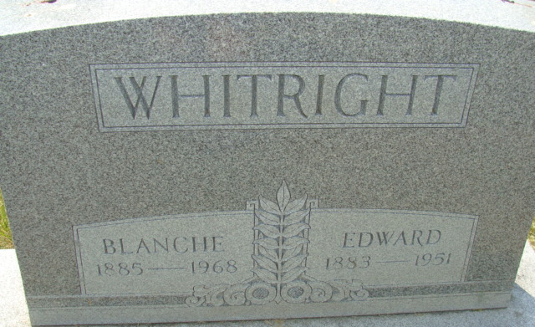
Photo by Alicia Kneuss

Ira Edward Whitright
in the Indiana, U.S., Death Certificates, 1899-2017
Name Ira Edward Whitright
Gender Male
Race White
Marital Status Married
Age 67
Birth Date 13 Sep 1883
Birth Place Allen County, Indiana
Death Date 2 Apr 1951
Death Place Decatur, Adams, Indiana, USA
Death Registration Date 1951
Father Abraham Whitright
Mother Ida Smith
Informant Mrs. Blanche Whitright; Decatur, Indiana
Burial April 5, 1951; Maplewood Cemetery; Decatur, Indiana

