Harry Elias Whitright
May 3, 1921 – December 11, 1922

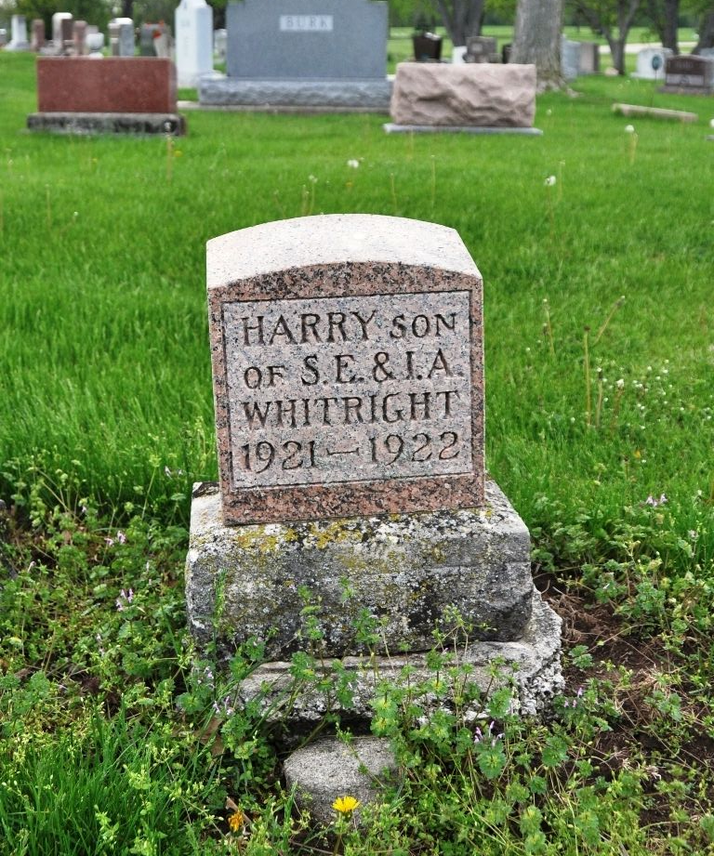
Photo by Deb Curry

One Of Whitright Twins Died Monday
Harry Elias Whitright, one of the twenty months old twin boys of Mr. and Mrs. Sam Whitright, died at the family home at 420 West Patterson Street at 10 o’clock yesterday evening, after an illness of only three days with bronchial pneumonia. The child was born in Decatur, May 3, 1921.
He is survived by the parents, and the following brothers and sisters: Naomi, Charles. Thelma. Freda, and his twin brother, Harold.
Funeral services will be held from the Evangelical Church at 2 o'clock Wednesday afternoon, the Rev. C. L. Haney, officiating. Interment will take place in the Decatur Cemetery.
Decatur Daily Democrat, Adams County, Indiana
Tuesday, December 12, 1922
**
Indiana, U.S., Death Certificates, 1899-2017
Name Harry Elias Whitright
Gender Male
Race White
Marital Status Single
Age 1
Birth Date 3 May 1921
Birth Place Adams County, Indiana
Death Date 11 Dec 1922
Death Place Decatur, Adams, Indiana, USA
Death Registration Date 1922
Father Sam Whitright
Mother Ida Johnson
Informant Ida Whitright; Decatur, Indiana
Burial December 13, 1922; Decatur Cemetery

